Tracing Gender in the Personal, Familial and Socio-Political History of
Nelson Mandela

A Public Lecture by Dr. Kammila Naidoo
Department of Sociology, University of Johannesburg, South Africa
Friday, April 5, 2019, 12pm, Student Center Room 330E
(Sponsored by University of Kentucky Sociology Department)

One of the most difficult tasks scholars may face is to map, in a succinct and relatively dispassionate way, the contribution made by an iconic or public figure in shaping national perceptions and policy. This is particularly true for gender as it is encompassed in both the personal and public practice of a life. In the case of Nelson Rolihlahla Mandela, a life lived in the limelight for much of his close to 100 years, one notes a progression and multi-dimensionality in reviewing his views of, and relationships with, women. While he is described as distinctly patriarchal, throughout his life he was drawn to and supported by strong-willed and powerful women. This article traces the reconfiguring of Mandela’s gendered thinking through different phases of his life as evident in biographies, media interviews, and various texts. The purpose is to identify philosophical and gendered tenets apparent in Mandela’s writings and life story as an invitation to renew critical debate about his legacy particularly as it pertains to gender, family life, and women’s emancipation.

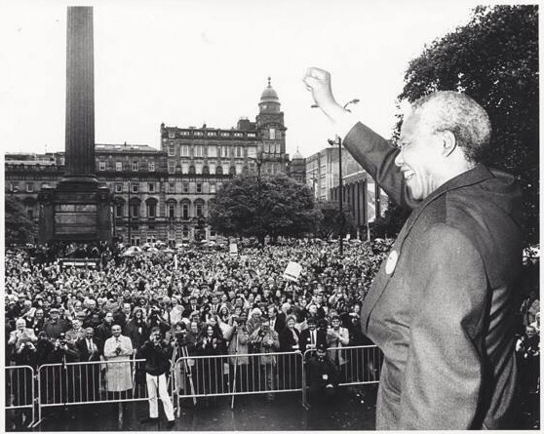

Kammila Naidoo lectures in the Sociology Department at the University of Johannesburg (UJ), South Africa, where she also serves as Vice Dean of Research (Faculty of Humanities). Prior to joining UJ, she taught at the University of Pretoria and the University of South Africa. Her doctoral work, which was completed at the University of Manchester, UK, was an ethnographic study exploring family dynamics and relationships, and the ways in which domestic violence reworked intimate unions. She has remained in touch with her fieldwork site for the past 16 years, tracking changes over time. She has published in the areas of family life, poverty and inequality, gender-based violence, and sexual and reproductive health.

