Rearranging courses in the Course List on the My Bb Page
To rearrange your courses and put them in a preferred order for you to see when you log into Blackboard, please follow these steps:
1. Navigate to your “My Bb” page. This is the same page that appears when you first log into Blackboard.
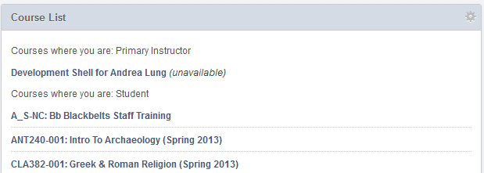
2. Once you are at “My Bb,” hover over your course list. A small gear should appear in the top right corner of the list.
STEP 2

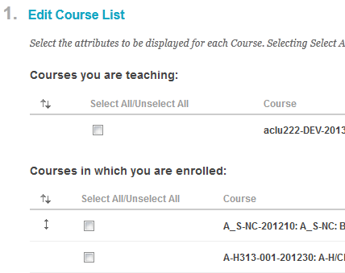
3. Once you click on the gear, it should take you to the “Personalize: Course List” page. Here, click on the double arrows next to the list you wish to modify.

STEP 3

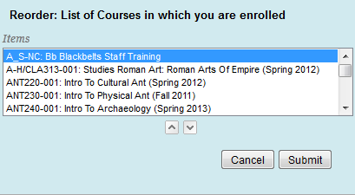
4. Once you click on the double arrows, a box should appear with a list of your courses. Select a course, then use the up and down arrows to navigate where you want to place this course. Once you are done, click Submit.
STEP 4

