Instructions for the Curricular Proposal System
Completing the Forms
Program proposals: email to rhanson@uky.edu
Accessing Blank Course Request Forms
From the desktop shortcut:
Double-click on the icon seen below.
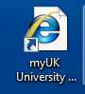
From the UK website:
Click on the “LINK BLUE” option. (Click refers to pressing the mouse button.)

From the following screen, left click on “myUK.”
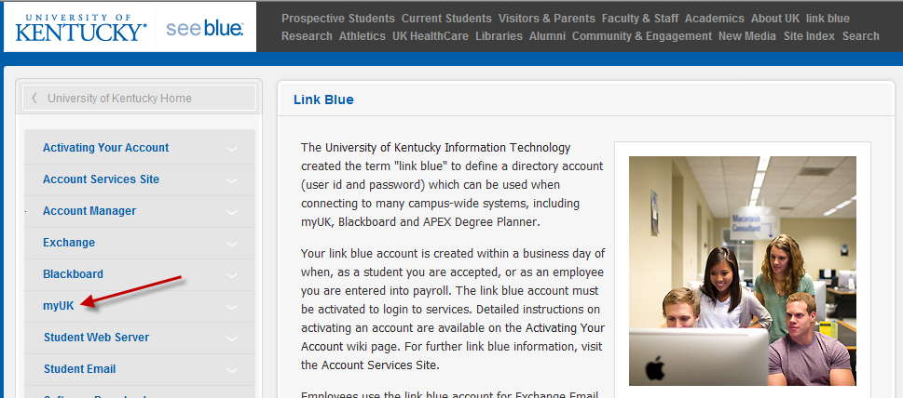
The following screen will then appear:
In the “User ID” field, enter your UK Link Blue ID, and in the Password field, enter your password. In many cases, this will be the same ID and password that you use to access your UK email account.
Left click on the “Sign On” button or press Enter.
You will then see this screen – although you may see fewer tabs across the top and fewer beach balls on the screen.

You are specifically looking for the tab titled “Enterprise Services.”
Next, select the “Enterprise Services” tab by left-clicking on the tab.
Once you’ve chosen “Enterprise Services,” most users will need to choose “Workflow” to bring up the Curricular Proposals menu. Left-clicking on the “Workflow” tab will select it for processing.

Now, left-click on the Curricular Proposal item on the left menu bar to select it for processing.
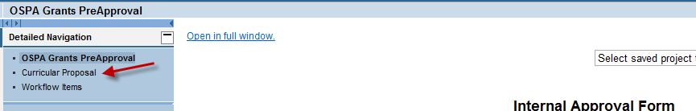

You will now see the menu of available forms for the Curricular Proposal system. To access the Curricular Proposal system, left-click on the desired form name.

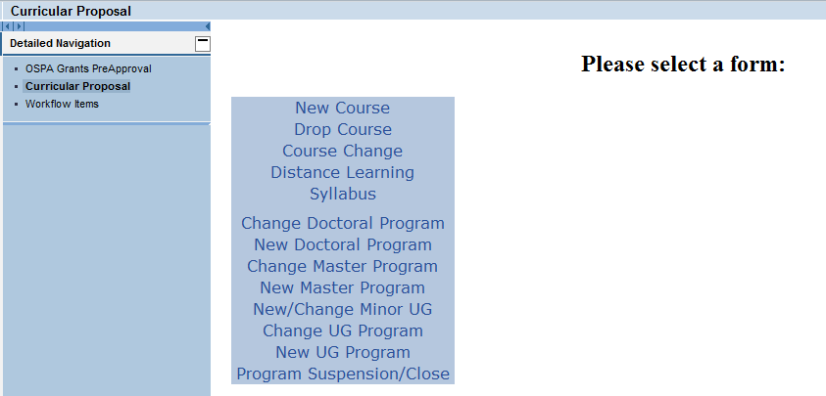

NOTE: Currently, use only the New Course, Drop Course, Course Change, Distance Learning and Syllabus form. The program forms will be available for use by the end of November, 2011.

These forms essentially request the same information as the adobe course request forms with which you’re familiar, with a couple of additions and with the information requested in a slightly different order.

Those fields with an asterisk are mandatory and you will not be able to submit the form if these items are left blank.

You should complete the form in the order the items are presented. You can, however, use the scroll bar at the far right to go up and down on the page / on your screen.

As you finish each field, hit tab to go to the next field for entry. You can also move your cursor to the beginning of the next field you would like to complete.

This form does not have to be fully completed in one sitting. Once you have chosen or entered a course prefix and number, the form may be saved and retrieved later by you or anyone else. Directions for this follow below.

The form may be prepared by the responsible Faculty person or any other individual with myUK access on the faculty member’s behalf.

Begin entry of the Drop Course Form with the Course Prefix and Number. Choose the course prefix from the drop-down list of valid prefixes from SAP.
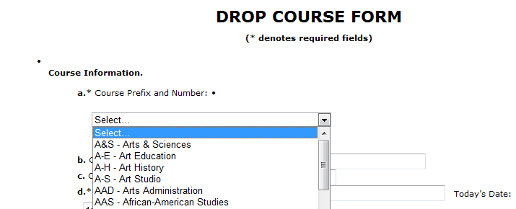
The form will then populate a drop-down list of the current courses associated with that prefix.
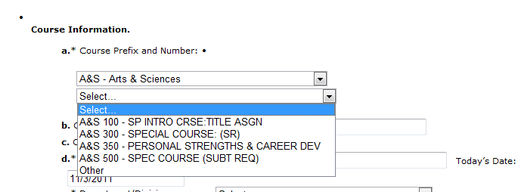
Choose the desired course from this list and the form will be populated with the course title, credit hours and College information. Complete the remaining fields on the form as appropriate.
You also begin entry of the course change form by choosing the appropriate course prefix and course number from the drop-down menus on the form. The form will then have current course information populated on the form where appropriate. However, the current contact hour information is not pre-populated but must be entered manually.
Enter ‘n/a’ or ‘same’ in any proposed text field which you will NOT change with this request.
SAVING AN INCOMPLETE CURRICULAR REQUEST FORM TO BE COMPLETED AND SUBMITTED LATER
At any point after the course prefix and number are completed, a partially-completed form may be saved for completion later or for completion by another person.
This “save” feature allows one person to begin a Curricular Request form and another person to complete it or submit it. Only the course title is needed for anyone to bring up an incomplete Curricular Proposal Form and complete it.
To save, scroll to the bottom of the form, and click on the “Save” button:

You may now either continue working on this form, or stop the process for resumption later.
From a blank Course Request form go to the upper right-hand corner and find the drop down box marked, “Select saved project to retrieve.”
Left-clicking on the downward facing arrow in this box will bring up a list of the titles of all saved and un-submitted forms (yours and others’ forms) from across the University.
Highlight the title of the form you wish to retrieve and click the button marked “Get.”
Adding Attachments to a Form
If you wish to add one or more attachments to a form before submission, go to the ‘Attachments:’ menu at the top left of the form.
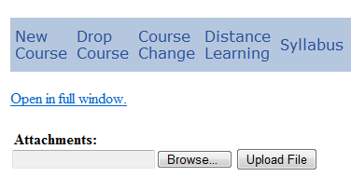
Select the ‘Browse…’ button to find the document to attach. All attachments will be associated with the request throughout the approval processing flow.

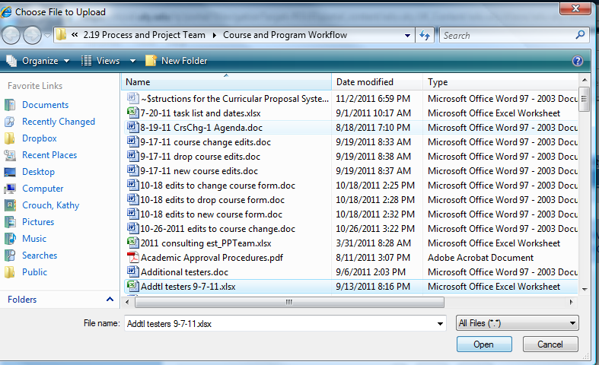

Select the Open button on the screen above to select the document and then select the ‘Upload Form’ button to complete the addition of the attachment to the form.

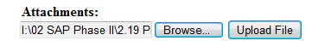

SUBMITTING A COMPLETED CURRICULAR PROPOSAL FORM
Once the Curricular Proposal form is complete, the form must be submitted before it moves through the work flow approval process.
To submit, scroll to the bottom of the form. There you will find a button marked, “Submit.”
Clicking this button will cause the form to begin processing and one of two things will result: 1) the form will be successfully submitted; or 2) error messages will be generated to point out those fields on the form which are preventing successful submission.
If the form is submitted successfully, a message stating that will appear at the top of the form:
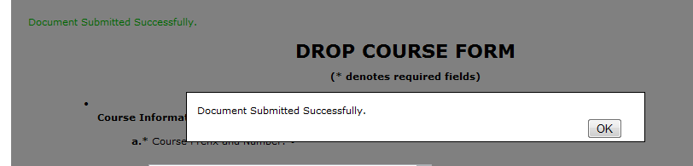
If the form is submitted unsuccessfully, then all errors in the form will be enumerated at the top of the form, and the fields in the form corresponding to these errors will be marked with a red asterisk.

Below are the error messages which appear when submitting a completely blank Drop Course form; this illustrates the type of messages that may appear:
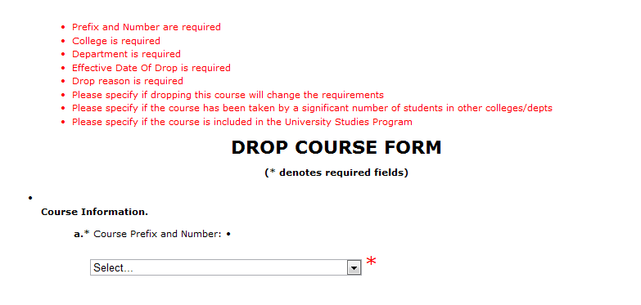
Each of these red error messages corresponds to a red asterisk which appears simultaneously within the form itself next to the field that requires attention. These red asterisks are larger than the black asterisks that denote a required field.

If you wish to save a copy of the submitted form, our recommendation is to save the submitted Curricular Proposal Form locally as an Adobe/pdf file (via the print option available on your computer).

E-MAIL NOTIFICATIONS TO SIGNATORIES OF A SUBMITTED CURRICULAR PROPOSAL FORM

Once the Curricular Proposal Form is successfully submitted, an email notification is sent from sender “Batch User” to the University of Kentucky parties who are responsible for reviewing or approving the request. The first email will go to the Chair or School Director of the department that owns the course on the request form.

It is important that you work with your IT department if emails sent to you about the Curricular Proposal Forms are ending up in your Junk E-mail folder.

